Name: Viernes, Michael Grade & Section: MAWD 401 Date: 4/10/2021

Objective: Create MySql Views.

1. A view called “SongIDAndGenre” is created by joining (INNER JOIN) two tables. It displays the Song ID, Genre Code, and Genre Description.

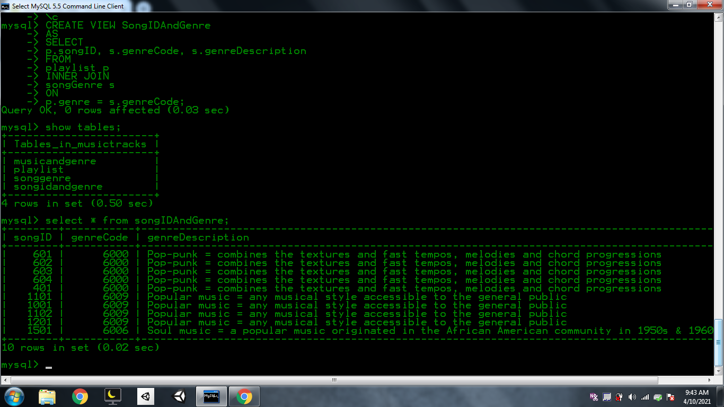

2. This is called “SongNameAndGenre” view that displays the titles, album, and description.

